Name: | Class:

① Listen and draw lines. Mark / 5

sister aunt father brother mother grandfather

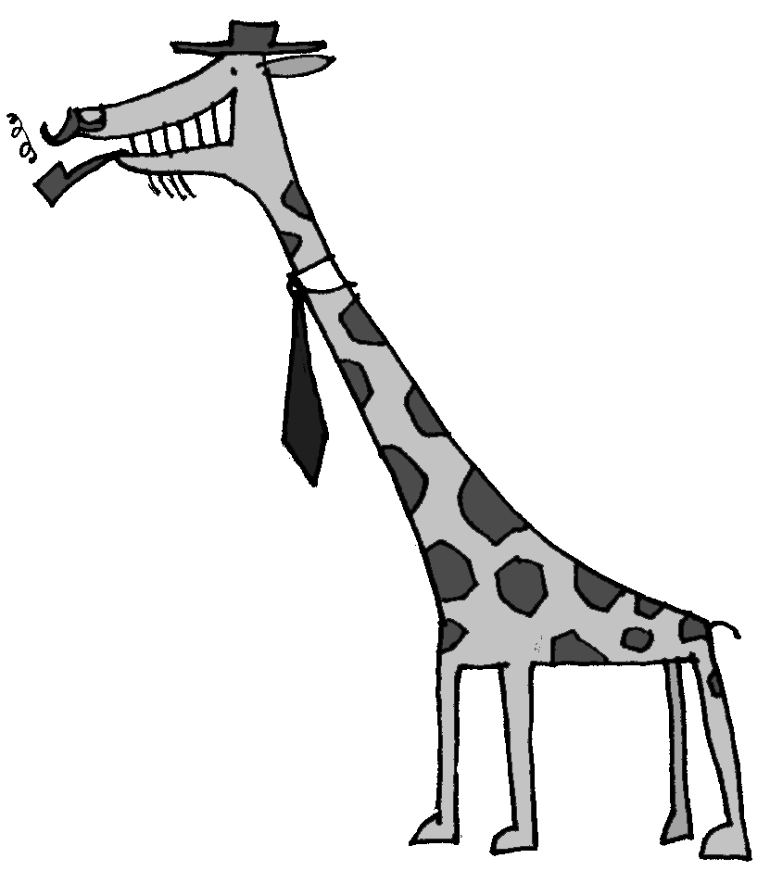
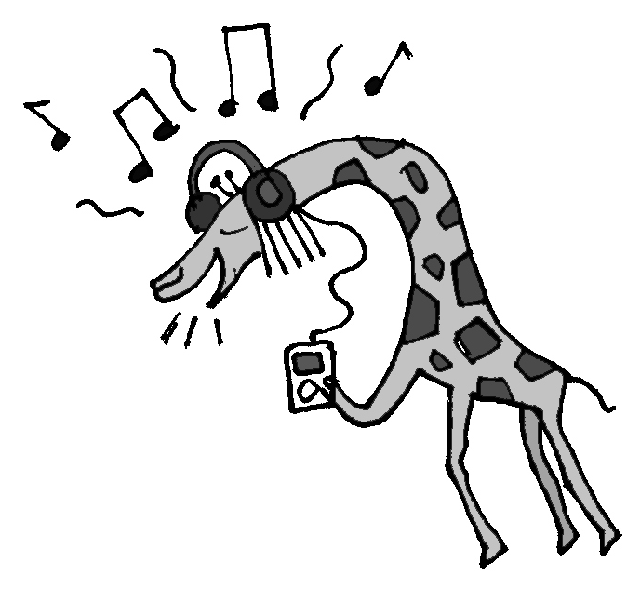
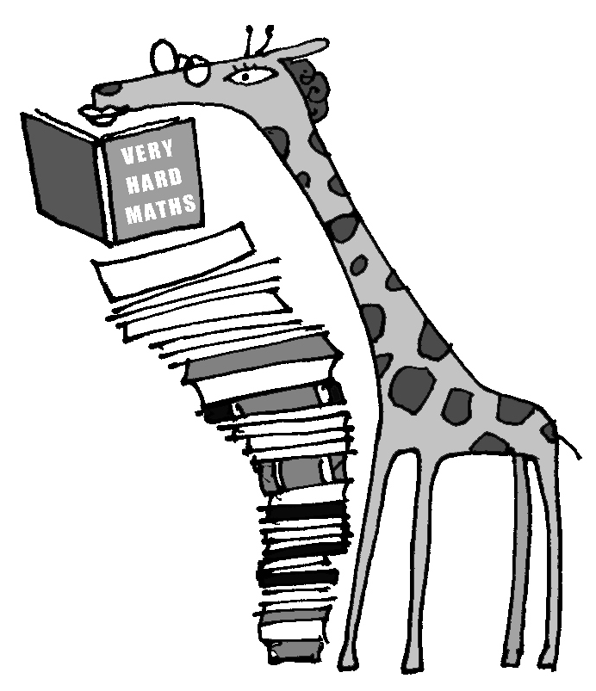
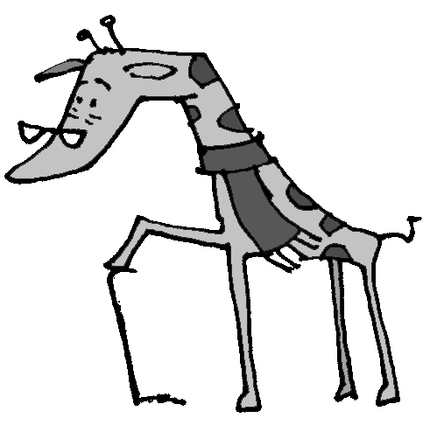
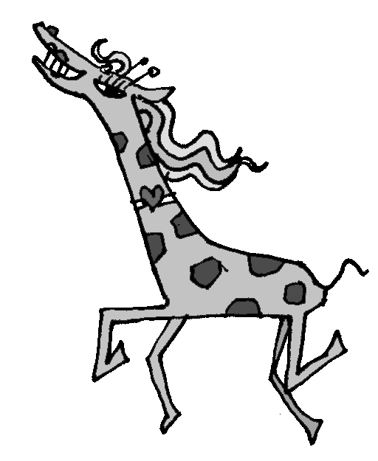
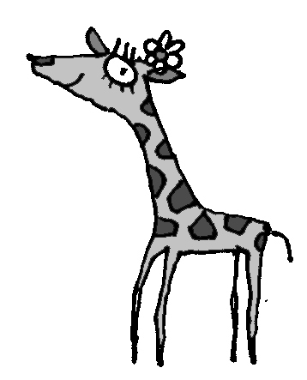

②Read and complete the text. Mark / 10
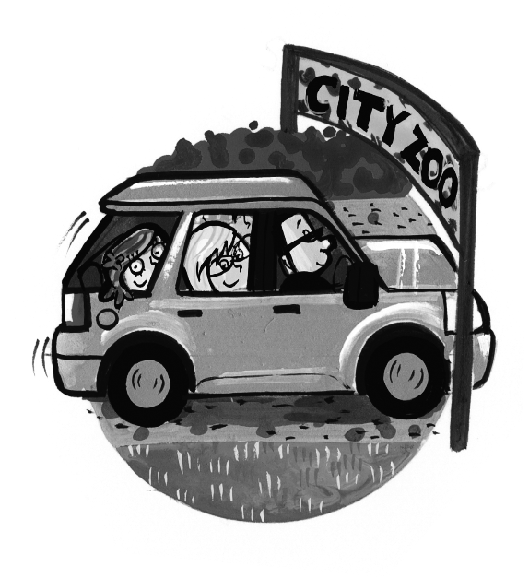
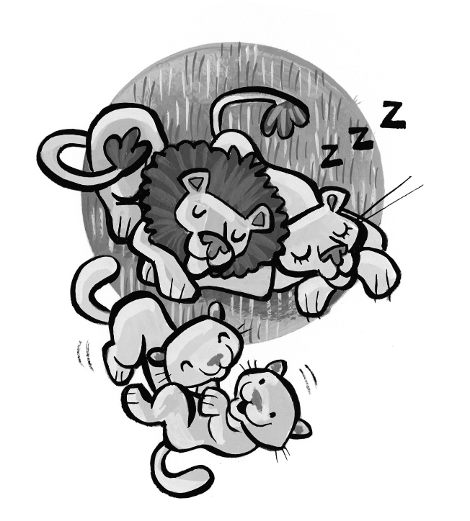
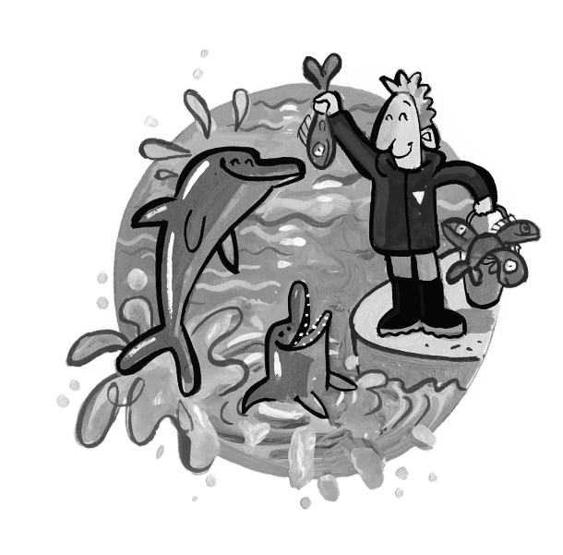
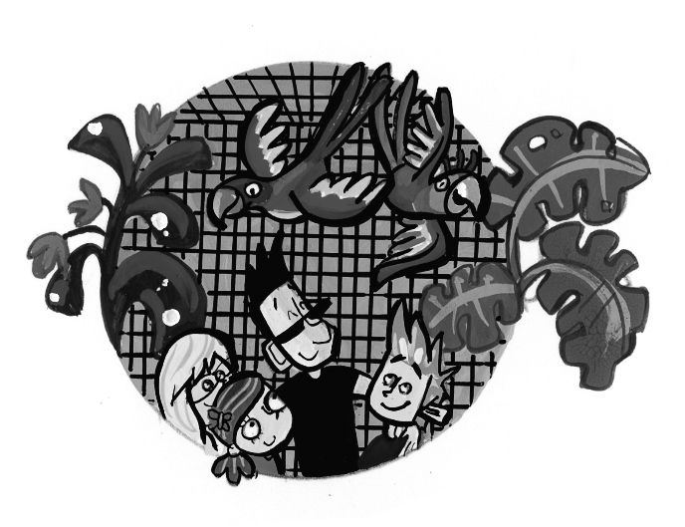
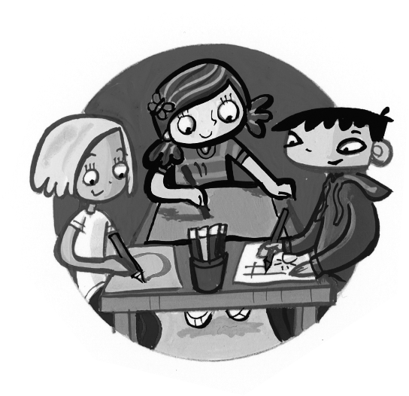
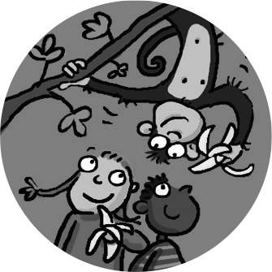

On Saturday we went (go) to the zoo. Dad ________ (drive) because he didn’t want to catch the bus. We ________ (see) lots of animals. The dolphins were my favourite. They ________ (swim)
in a pool and ________ (catch) fish. The parrots were beautiful and they ________ (fly) round their big cage. The monkeys ________ (eat) bananas and the lions ________ (sleep) on the grass. I ________ (see) a lizard. He ________ (catch) a fly! We ________ (draw) pictures of all the animals.

Total unit mark / 15

