Name: | Class:

①Write the words. Mark / 5
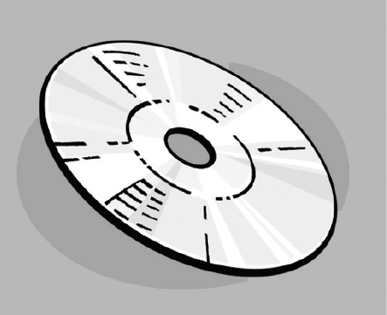
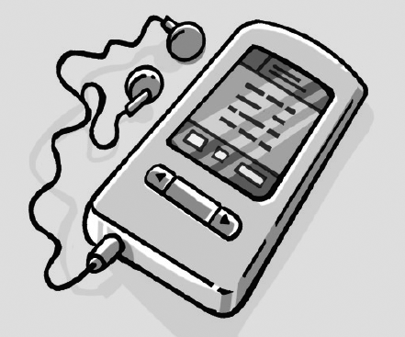
❶ DVD ❷


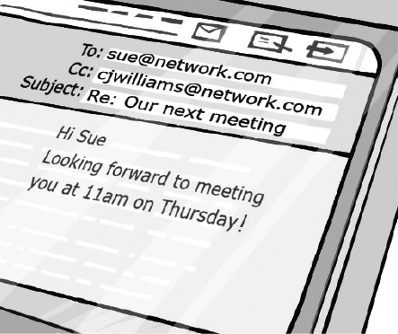

❸ ❹




❺ ❻

②Complete the sentences with the past Mark /10
of the verbs.

read buy know say choose bring

❶ She chose a good DVD to watch.
❷ She __________ ‘Hello’.
❸ He __________ all the answers.
❹ She __________ a book last night.
❺ He __________ his MP3 player to the party.
❻ She __________ a new computer.

Total unit mark / 15

