Name: | Class:

①Read and match. Mark / 5

❶ Peter couldn’t go to school. a He took a lot of photos.
❷ Mary came to my house. b He had a temperature.
❸ Daisy lost her bag. c Grandma was happy.
❹ John got a new camera. d We caught the bus to town.
❺ Lucy made a cake for Grandma. e Mum found it in the hall.
❻ We went shopping. f I went to her house on Saturday.

②Look and write. Mark / 10

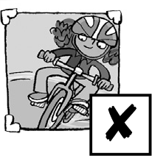
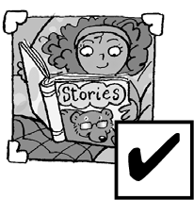
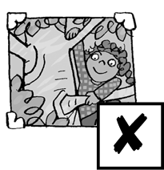
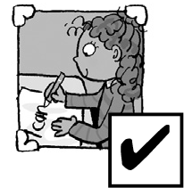
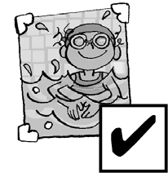
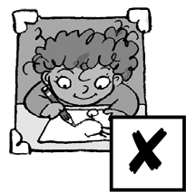
❶ ❷ ❸ ❹ ❺ ❻

❶ Could Jane ride a bike when she was one?
❷ Could Jane r__________ when she was six?
❸ Could Jane c__________ a tree when she was two?
❹ Could Jane w__________ when she was six?
❺ Could Jane s__________ when she was five?
❻ Could Jane d__________ a picture when she was three?

❶ No, she couldn’t ❷ ____________
❸ ____________ ❹ ____________
❺ ____________ ❻ ____________

Total unit mark / 15

