Name: | Class:

①Read and complete the text. Mark / 5

went had was gave took ate drank

Last night I went to bed early because I was really tired. In the morning I a headache. I lots of water. At lunch time, I some rice. In the afternoon,
Mum me to the doctor. He me some medicine. In the evening I better!

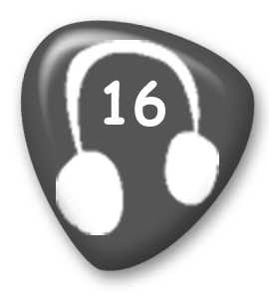
② Listen and draw lines. Mark / 10
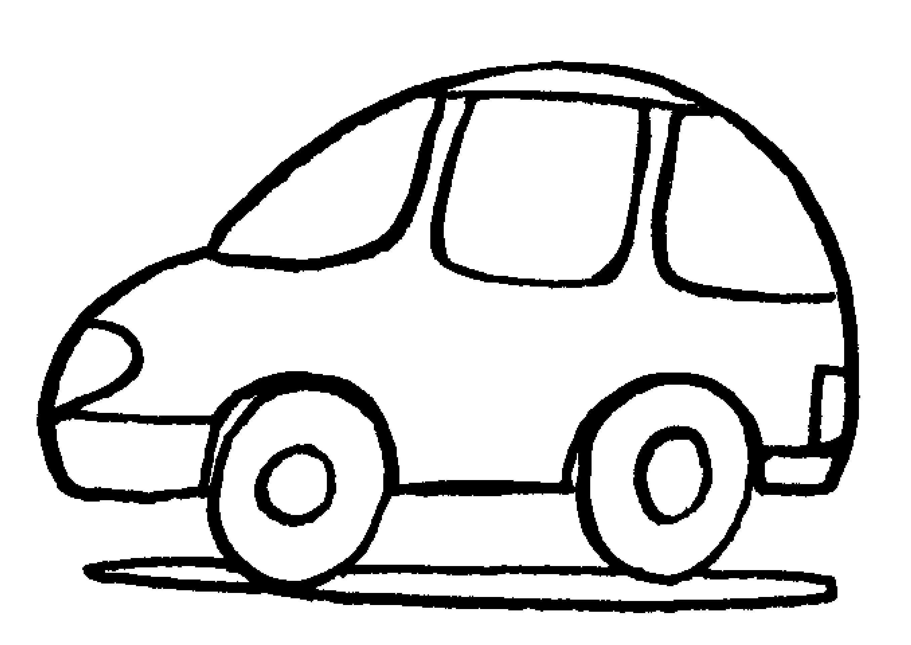
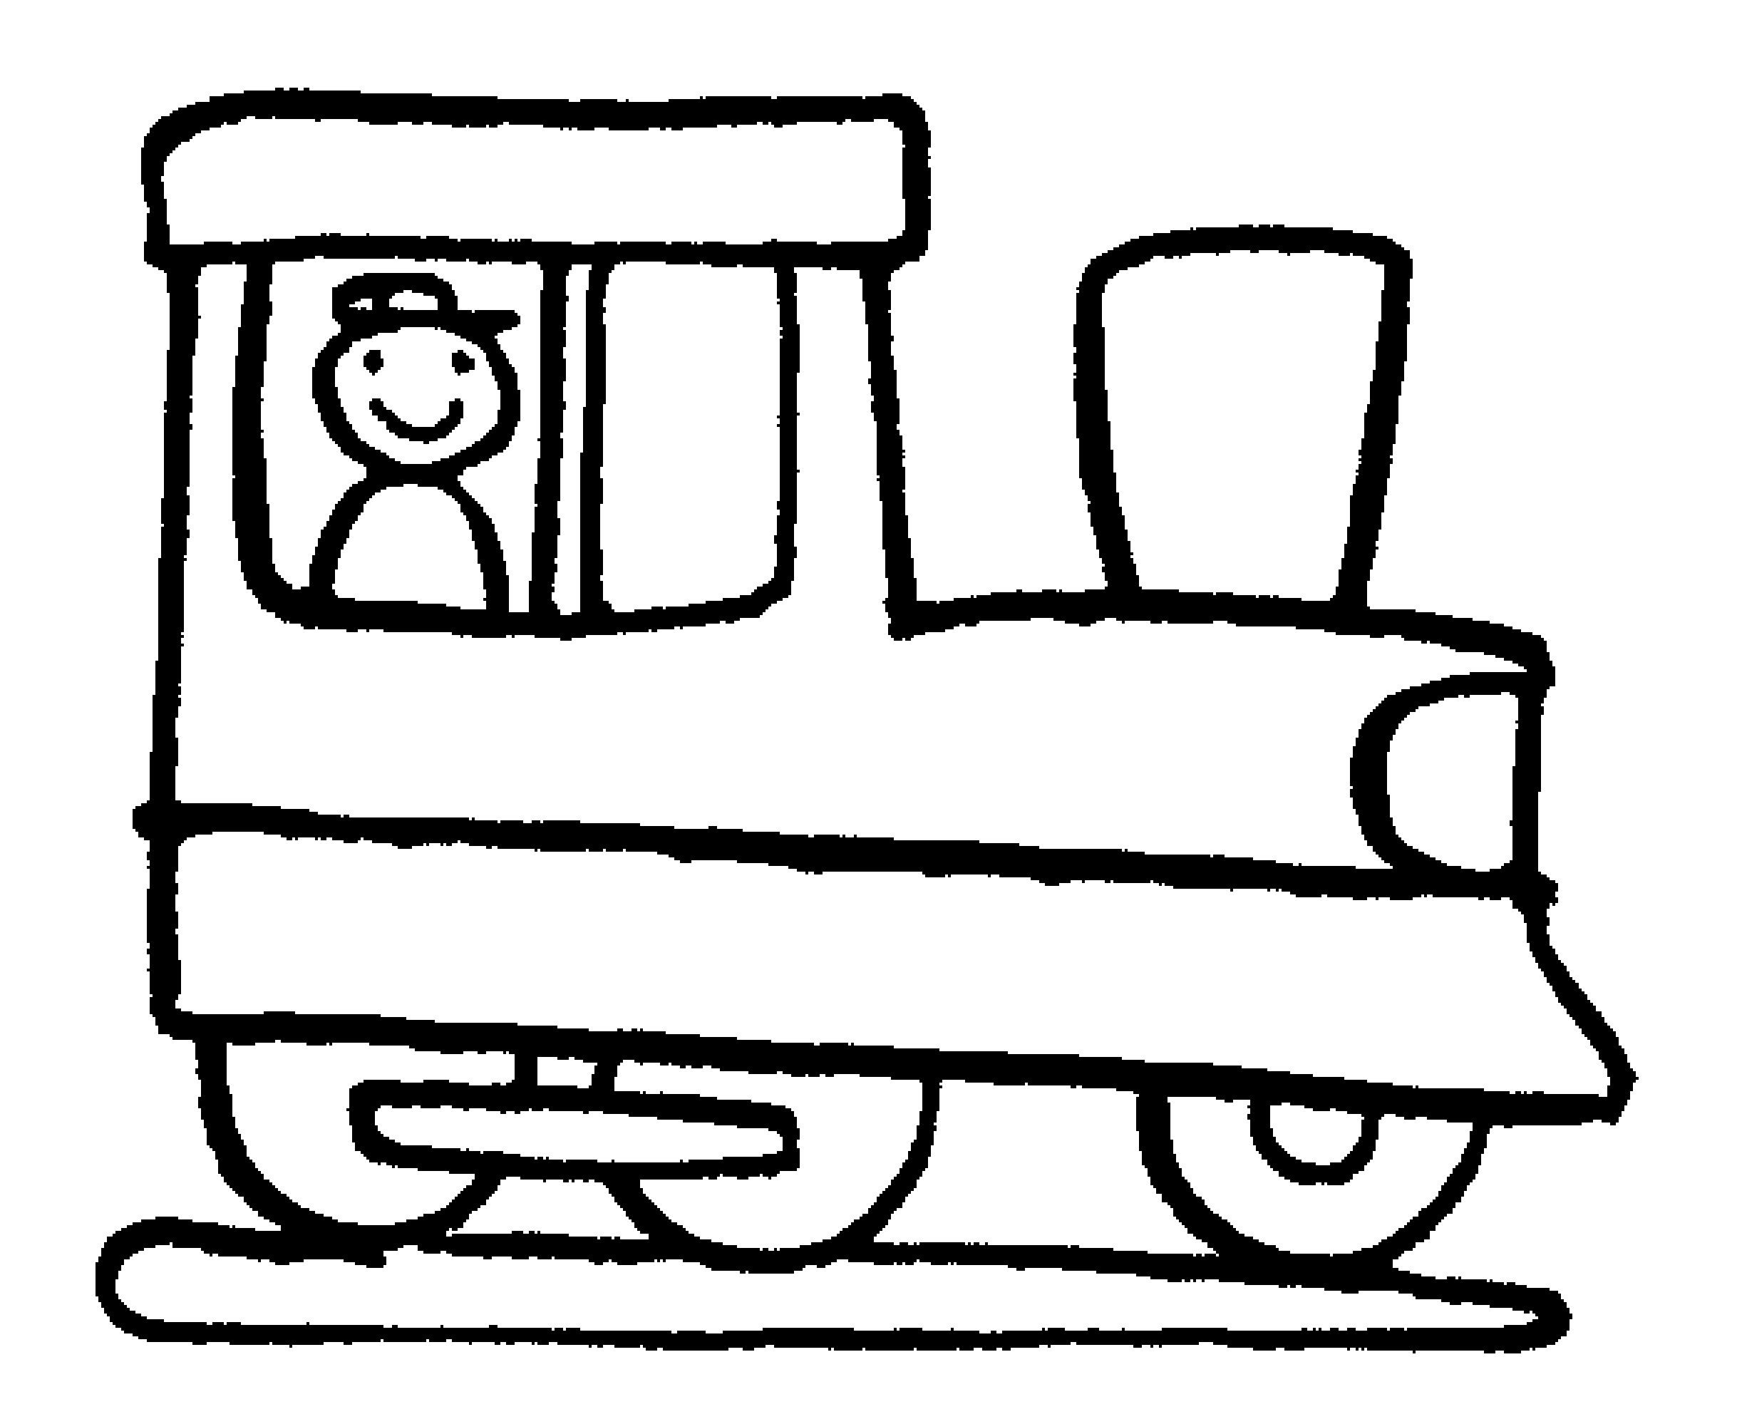
12th

5th

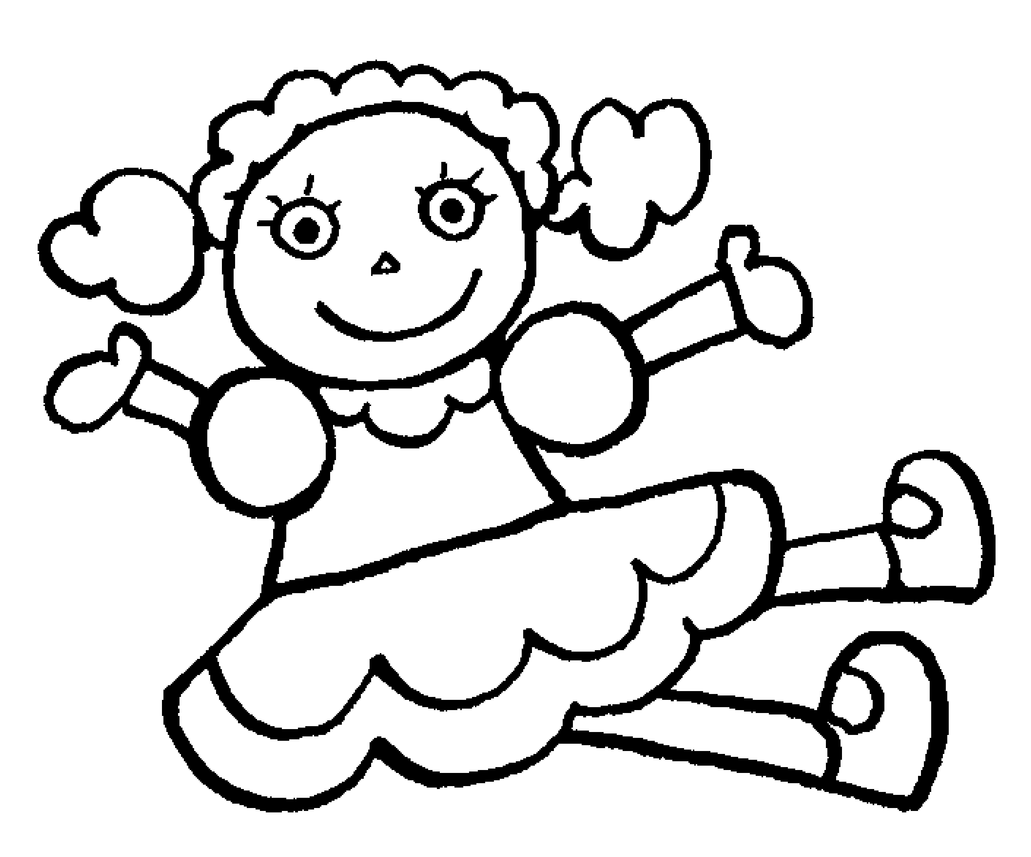
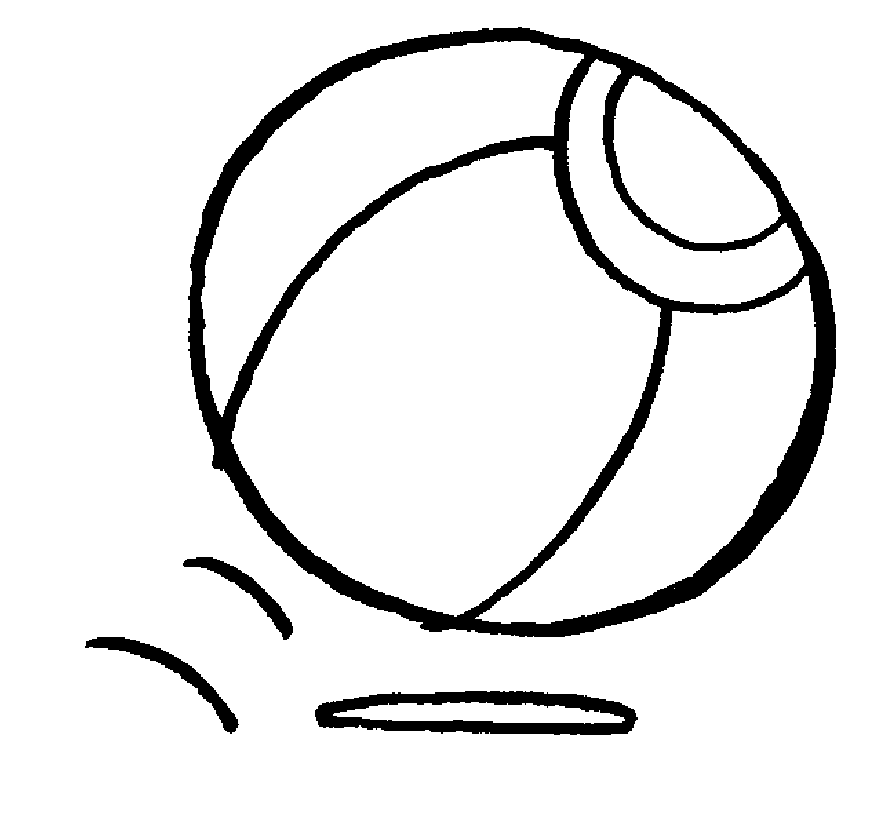
20th

3rd

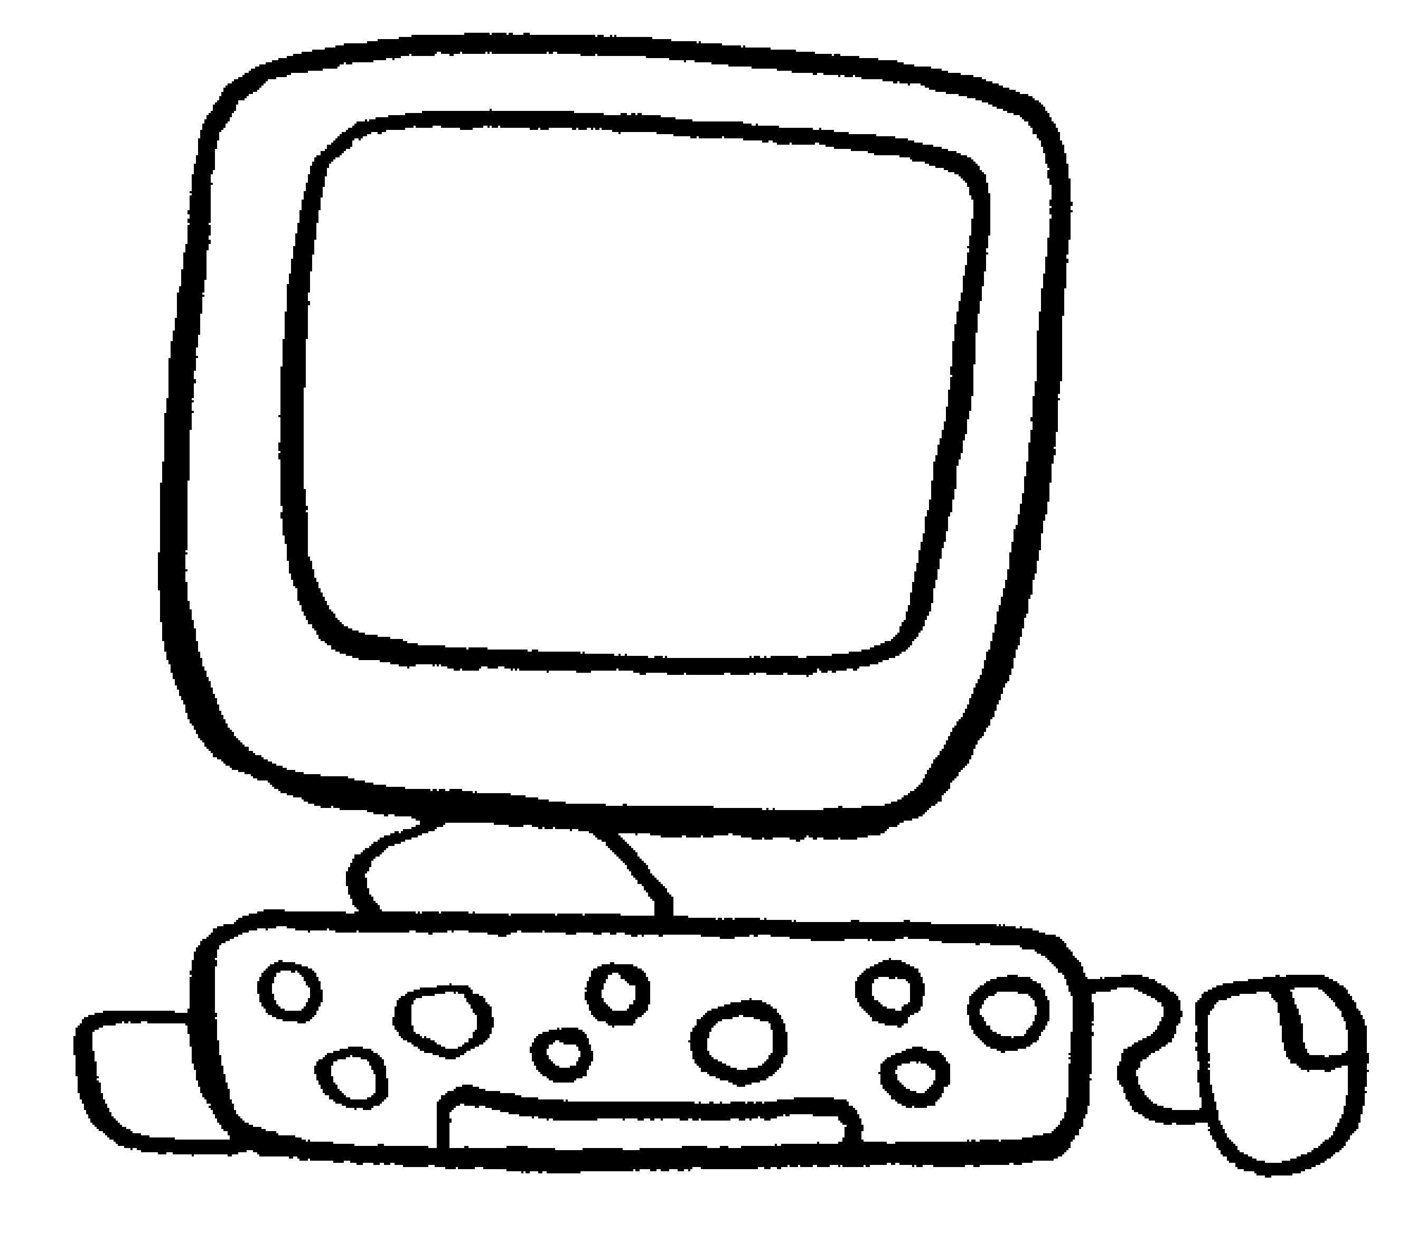
1st

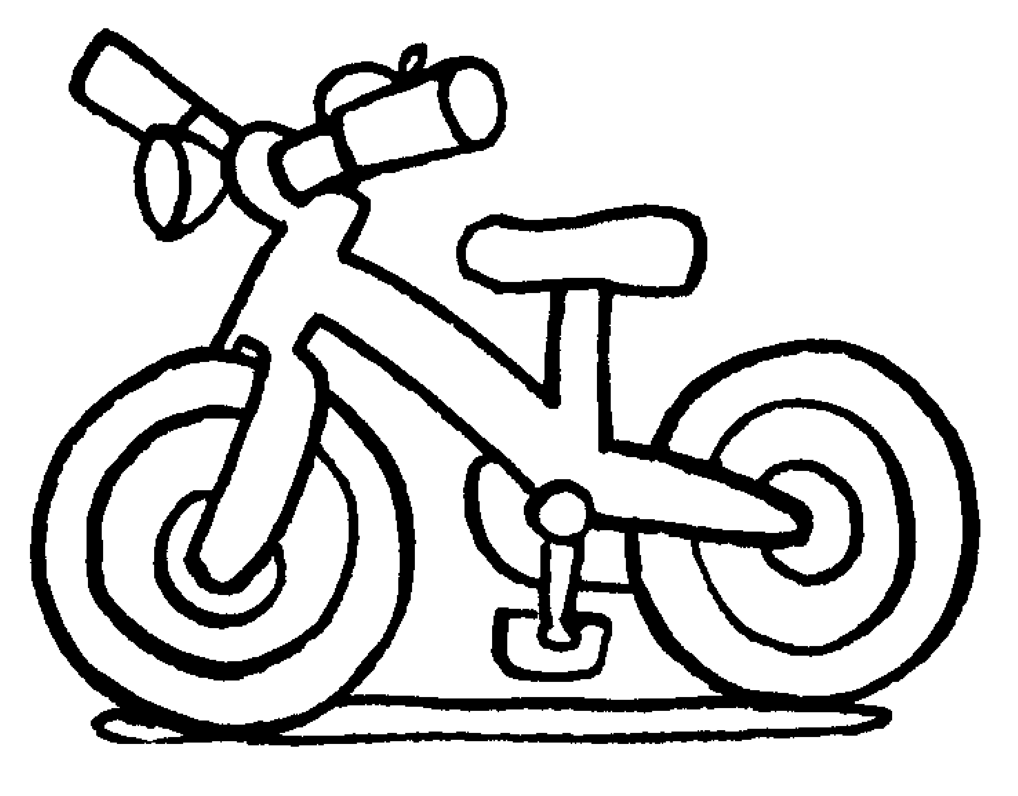
2nd

Total review mark / 15

