Name: | Class:

①Look and write. Mark / 5

careful terrible boring exciting quick slow

❶ 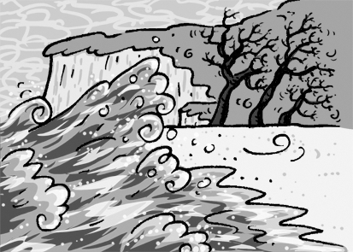 ❷ 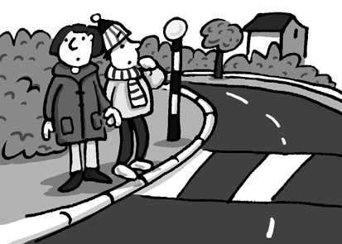 ❸ 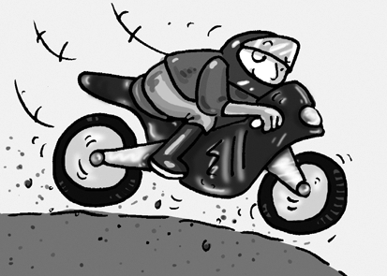
t e r r i b l e _ _ _ _ _ _ _ _ _ _ _ _
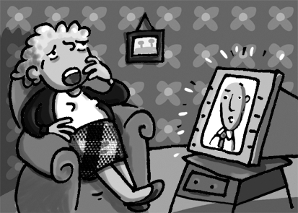
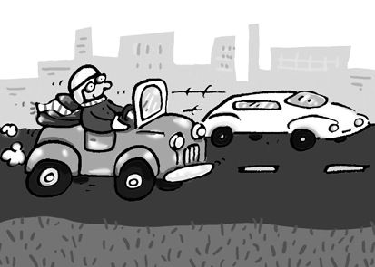


❹ ❺ ❻
_ _ _ _ _ _ _ _ _ _ _ _ _ _ _ _ _ _

② Listen and number. Mark / 10
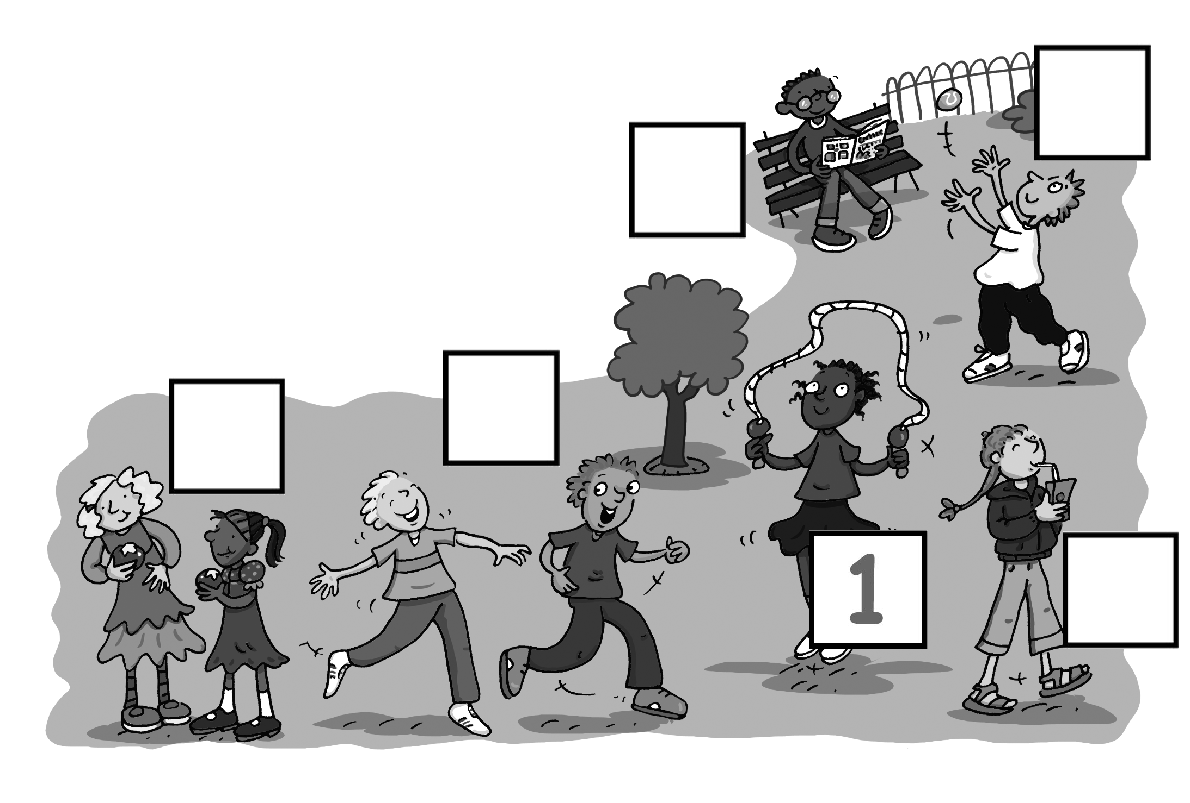

Total unit mark / 15

