Name: | Class:

①Match and write. Mark /8

busy careful terrible easy exciting


❶ The boy with curly black hair loves English.
He’s careful with his homework.

❷ The girl with straight blonde hair thinks
Music’s . She wants to be a singer.

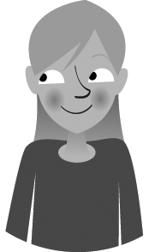
❸ The girl with short curly black hair and glasses likes having lots of things to do. She likes being .
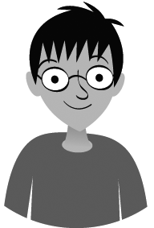
❹ The boy with curly blonde hair thinks Art’s boring.
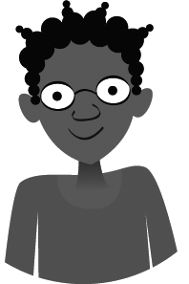
His pictures are .

❺ The boy with straight black hair and glasses thinks
Maths is , not difficult.

②Read and write. Mark / 7

❶ You can play basketball inside here. sports centre
❷ You can learn here. c
❸ You can fly a kite here. p
❹ You can fish here. r
❺ You mustn’t skate here. r
❻ You can sail here. l______________________
❼ You can have a wash here. b______________________
❽ You can eat breakfast here. k______________________

Total review mark / 15

