

1 Look and write. (5 marks)
2 careful, 3 quick, 4 slow, 5 boring, 6 exciting

2 Listen and number. (10 marks)
boy who’s reading – 4, boy who’s playing with a ball – 5, girls who are eating apples − 2,
boys who are laughing – 6, girl who’s drinking juice – 3

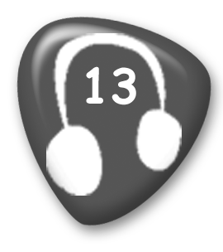
1 She’s the girl who’s skipping.
2 They’re the girls who are eating apples.
3 She’s the girl who’s drinking juice.
4 He’s the boy who’s reading.
5 He’s the boy who’s playing with a ball.
6 They’re the boys who are laughing.



1 Circle and write. (8 marks)
2 doesn’t want, dance, 3 wants, skate, 4 want, sail, 5 doesn’t want, climb,
6 don’t want, fish, 7 wants, climb, 8 doesn’t want, skate, 9 wants, sail

2 Listen and number. (7 marks)
riding carefully – 4, running slowly – 3, shouting loudly – 7, playing badly – 8,
playing well – 6, reading quietly – 2, running quickly – 5

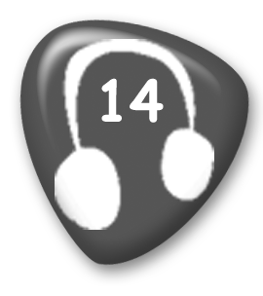
1 She’s riding her bike quickly.
2 They’re reading quietly.
3 They’re running slowly.
4 He’s riding his bike carefully.
5 They’re running quickly.
6 He’s playing well.
7 They’re shouting loudly.
8 He’s playing badly.

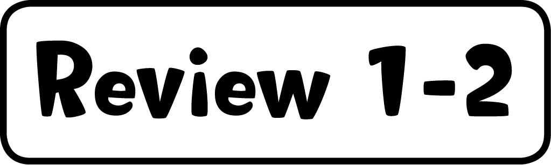

1 Match and write. (8 marks)
2 girl with straight blonde hair, exciting, 3 girl with short curly black hair and glasses, busy, 4 boy with curly blonde hair, terrible, 5 boy with straight black hair and glasses, easy

2 Read and complete the text. (7 marks)
2 classroom, 3 park, 4 river, 5 road, 6 lake, 7 bathroom, 8 kitchen



1 Write the past of the verbs. (9 marks)
2 had, 3 drank, 4 saw, 5 gave, 6 took, 7 went, 8 ate, 9 did, 10 was/were

2 Listen and tick or cross. (6 marks)
2 , 3 , 4 , 5 , 6 , 7 

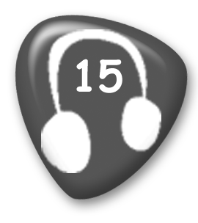
1 He had a cold yesterday.
2 She had a headache last night.
3 He had a temperature yesterday.
4 She had a cough last night.
5 He had a toothache last night.
6 They had headaches last night.
7 She had an eye test yesterday.



1 Read and complete the text. (12 marks)
helped, cooked, played, danced, stopped, jumped

2 Write the answers. (3 marks)
2 Yes, they did. 3 Yes, they did. 4 No, they didn’t.

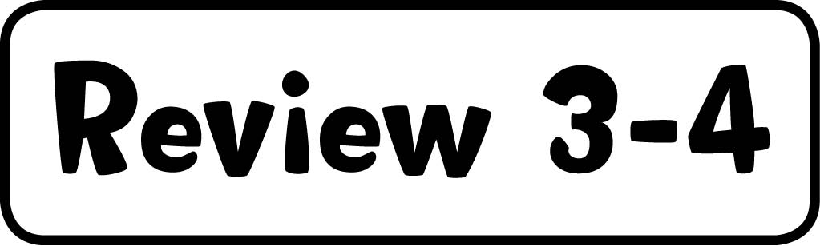

1 Read and write. (5 marks)
had, drank, ate, took, gave, was

2 Listen and draw lines. (10 marks)
ball–2nd, train–3rd, bike–5th, computer–12th, car–20th

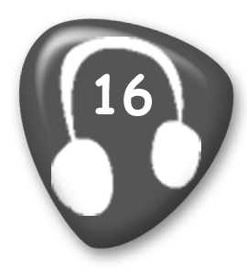
Daisy got a doll for her first birthday. She got a ball for her second birthday. She got a train for her third birthday. She got a bike for her fifth birthday. She got a computer for her twelfth birthday. She got a car for her twentieth birthday.



1 Read and match. (5 marks)
2 f, 3 e, 4 a, 5 c, 6 d

2 Look and write. (10 marks)
2 read, Yes, she could. 3 climb, No, she couldn’t. 4 write, Yes, she could.
5 swim, Yes, she could. 6 draw, No, she couldn’t.



1 Write the words. (5 marks)
2 MP3 player, 3 computer screen, 4 email, 5 computer mouse, 6 button

2 Complete the sentences with the past of
the verbs. (10 marks)
2 said, 3 knew, 4 read, 5 brought, 6 bought

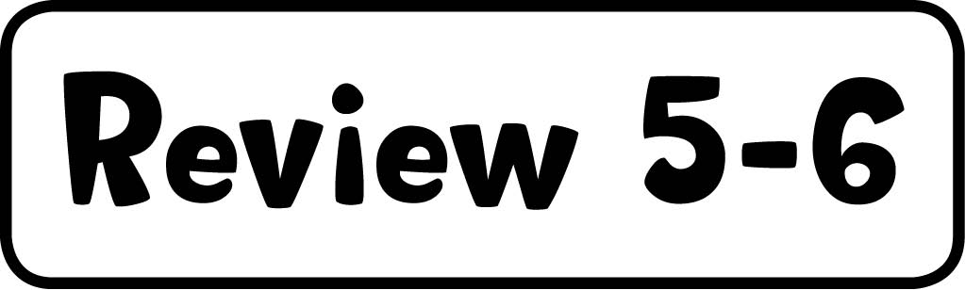

1 Listen and number. (6 marks)
Simon and Stella – 4, Mr Star and Grandma – 2, cat and dog – 3, horse and dog – 7, elephant and dog – 5, boy and girl – 6

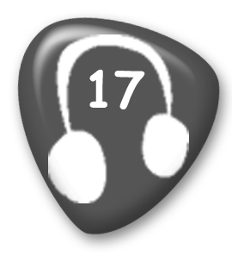
1 The monkey’s happier than the panda.
2 Mr Star’s more famous than Grandma.
3 The dog’s dirtier than the cat.
4 Simon’s hungrier than Stella.
5 The elephant’s stronger than the dog.
6 The girl’s more careful than the boy.
7 The horse is thirstier than the dog.

2 Read and match. (9 marks)
2 g, 3 i, 4 a, 5 d, 6 b, 7 c, 8 h, 9 e, 10 j



1 Listen and draw lines. (5 marks)
father – tallest, mother – cleverest, sister – youngest, brother – loudest,
grandfather – oldest


In the giraffe family, aunt giraffe is the most beautiful. Father giraffe is the tallest. Sister giraffe is the youngest. Grandfather giraffe is the oldest. The cleverest giraffe in the family is mother giraffe. Brother giraffe is the loudest giraffe in the family.

2 Read and complete the text. (10 marks)
drove, saw, swam, caught, flew, ate, slept, saw, caught, drew



1 Look and write. (10 marks)
2 a bowl of pasta, 3 a bottle of water, 4 a cup of coffee,
5 a glass of lemonade, 6 a box of eggs

2 Listen and number. (5 marks)
text – 5, make coffee – 3, clean the table – 4, sit down – 6, turn on computer – 2


1 Simon wants Stella to open the window.
2 Grandpa Star wants Grandma Star to turn on the computer.
3 Mrs Star wants Mr Star to make some coffee.
4 Stella wants Suzy to clean the table.
5 Grandpa Star wants Grandma Star to text Simon.
6 The teacher wants them to sit down.

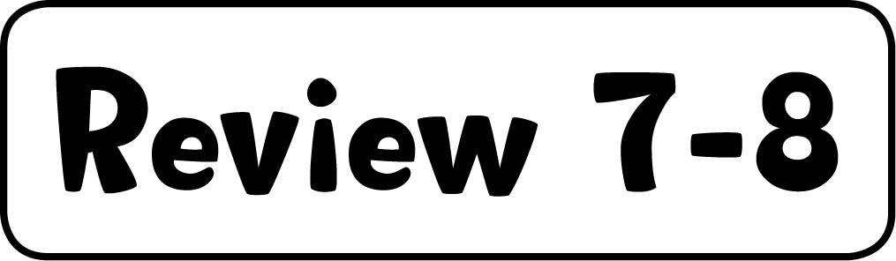

1 Read and complete the sentences. (10 marks)
2 The men came out of the lift.
3 The children ran round the playground.
4 The children walked into school.
5 The old lorry came round the mountain.
6 The children ran out of school.

2 Read and complete the sentences. (5 marks)
2 quickly, 3 carefully, 4 slowly, 5 best, 6 worst



1 Look and write. (5 marks)
2 exciting, 3 terrible, 4 easy, 5 quick, 6 careful

2 Read and match. (5 marks)
2 He ate a big dinner because he was hungry.
3 I gave him some medicine because he had a cough.
4 She went to bed early because she was tired.
5 I saw the doctor because I had a stomach-ache.
6 She took some medicine because she had a headache.

3 Read and write. (5 marks)
2 hers, 3 his, 4 mine, 5 yours, 6 ours

4 Listen and write. (10 marks)
2 bottle, water, 3 cup, tea, 4 glass, lemonade, 5 bag, potatoes, 6 box, sugar


A bowl of soup. A bottle of water. A cup of tea. A glass of lemonade. A bag of potatoes.
A box of sugar.

