Name: | Class:

①Look and write. Mark / 10
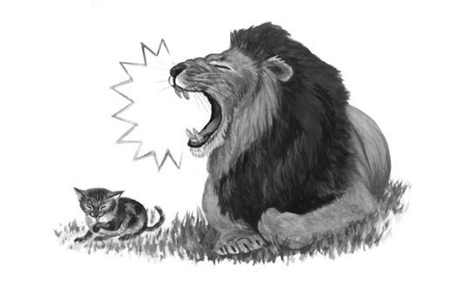
❶ The cat is quieter than the lion. quiet

❷ The lion ______________________ strong

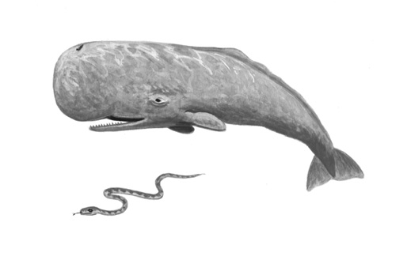
❸ The whale ____________________ big

❹ The snake ____________________ thin
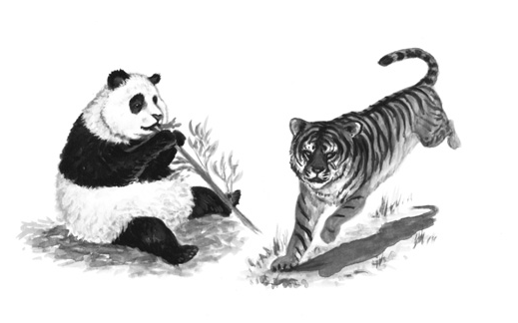

❺ The panda ____________________ fat

❻ The tiger ____________________ quick

②Read and circle. Mark / 5


❶ We wasn’t / weren’t at the beach yesterday.

❷ I was / were at home yesterday.

❸ It was / wasn’t sunny yesterday. It was cloudy.

❹ They were / weren’t at school yesterday. It was Sunday!

❺ Where were / was you yesterday?

❻ It was / were snowing yesterday, but today it’s raining.

Total unit mark / 15

